# 30A –Mutual Inductance

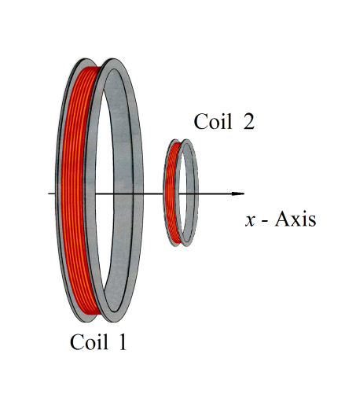**Background**: We have learned that *EMF* across a coil creates a current that creates a magnetic field. We have also learned that changing magnetic flux through a coil creates an *EMF* in that coil. This means that an oscillating *EMF*1 - fed into one coil causes an oscillating *EMF*2 - in the second coil. This is the basis for a useful device called a transformer.

We will work here through the relationship between currents and *EMF*’s in two coils for a special case as sketched to the right. The coils are coaxial.

The large coil in the sketch is Coil 1. It has *N*1 turns and radius *R*1. The smaller coil is Coil 2 with *N*2 turns and radius *R*2.

1. What is the magnetic field at the center of a circular coil of wire with *N*1 turns, radius *R*1, and current *I*?

*B1* =____________________T

1. Assuming Coil 1 produces a magnetic field *B*1, find the flux through one turn of Coil 2.

Φ2 =________________T-m2

1. Write the EMF - $ℇ_{2}$ generated in Coil 2 due to a time dependent magnetic flux Φ2(t).

=___________________V

1. The mutual inductance between Coil 1 and 2 is defined by the relation *EMF2*  - ,  
   . Find *M*21 in terms of some or all the variables *N*1, *N*2, *R*1, and *R*2 by comparing your result in section 3 to this definition.

*M*21 =________________H

# 30B – Experiment: *EMF* and d*I*/d*t* Relationship in an Inductor

If current varies in an inductor a “back” EMF - $ℇ_{L}$ is produced in the inductor to resist the change in current. This relation is described by:

$$ℇ_{L}= -L {di}/{dt}$$

**Background calculations**

The resistor, inductor, and driving frequency in this experiment are chosen so that the current in the circuit is limited by the resistor, so . The EMF across the inductor is thus $$ℇ_{L}= -L \frac{di}{dt}=-\frac{L}{R}\frac{{dV}_{FG}}{dt} .$$

1. If the current in an inductor, *L* = 6.0 mH, varies linearly from 0 to +1.0 mA in 1/100 seconds, what is the *EMF* - $ℇ_{L}$ induced across the inductor?

$ℇ_{L}=$_______________V

1. The current in a 12.5 mH inductor varies like a “triangle” wave as sketched below in the lower left graph. The amplitude of the current *iL*(max) = 2 mA and the period *T* = 5.0 ms.

a) For the current graph, label the horizontal and vertical axis and include scale.

b) Sketch the back EMF - $ℇ_{L}$ as a function of time on lower right grid. Label the

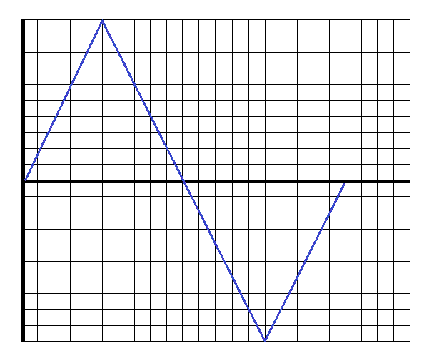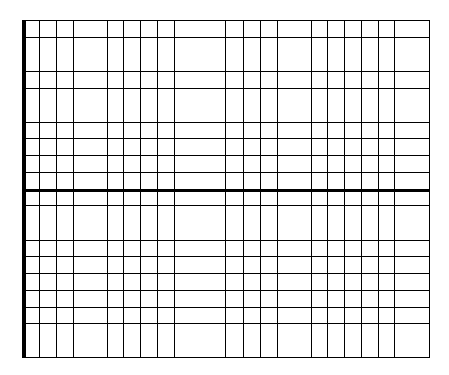 horizontal and vertical axes and include scale.

.

# Activity 30B_M1K – Experiment: Inductance and Changing Current

This experiment allows you to explore the relationship between a changing current and the resultant EMF generated across an inductor.

You will use the ADALM1000 (M1K) or similar board, a 4.7 mH inductor, a 1000 Ω resistor, the electronic breadboard, and three jumper wires for this experiment. Refer to the Supplementary Section at the end of this activity description (p. 10) if you are unfamiliar with the use of electronic breadboards and the M1K USB board.

**Setting up the M1K**

Open the ALICE M1K Desktop and plug in the M1K.

* Set up your breadboard with the 1000 Ω resistor (Brown – Black – Red) and the 4.7 mH inductor wired in series. An example is shown in the image below. A picture containing text

  Description automatically generated

**Figure 1**. The series L-R circuit, with jumper wire connections.

* Wire Ch A to the far side of the resistor (blue wire seen in row 24 of the breadboard in the figure above) and the 2.5 V output to the other end of the circuit at the far side of the inductor (light brown wire in row 3 of the breadboard in the figure). Wire Ch B to the junction where the inductor and resistor connect to each other (green wire in row 11 of the breadboard in the figure above). Ch A will show the triangle wave voltage being applied to the circuit, and Ch B will show the potential across the inductor.
* Set up the ALICE oscilloscope using Ch A as the potential source.
  + Use the AWG Configuration Panel to set up the measurement channels.
    - AWG CH A
      * Mode = SVMI with Term = To 2.5
      * Shape=**Triangle**; Freq Ch A=5000 Hz
      * Min Ch A = 1.0; Max Ch A = 4.0
    - AWG CH B to Hi-Z with Term=Open (This disconnects B from its source voltage. Other settings are unimportant.) Also, uncheck Sync AWG.
  + On the menus bar across the top of the oscilloscope frame
    - Curves menu, choose CA-V and CB-V
    - Trigger menu select CA V and Auto level.
    - Edge menu = Rising
    - Time mS/Div = 0.02 mS/Div
  + On the settings bar across the bottom of the oscilloscope select CA V/Div, CA V Pos, CB V V/Div, and CB V Pos to get both Ch A and Ch B Voltage on the screen with each signal filling most of the vertical range. (You will find it best to set the CA and CB V Position to 2.5 V.) An example screen is shown below.
  + 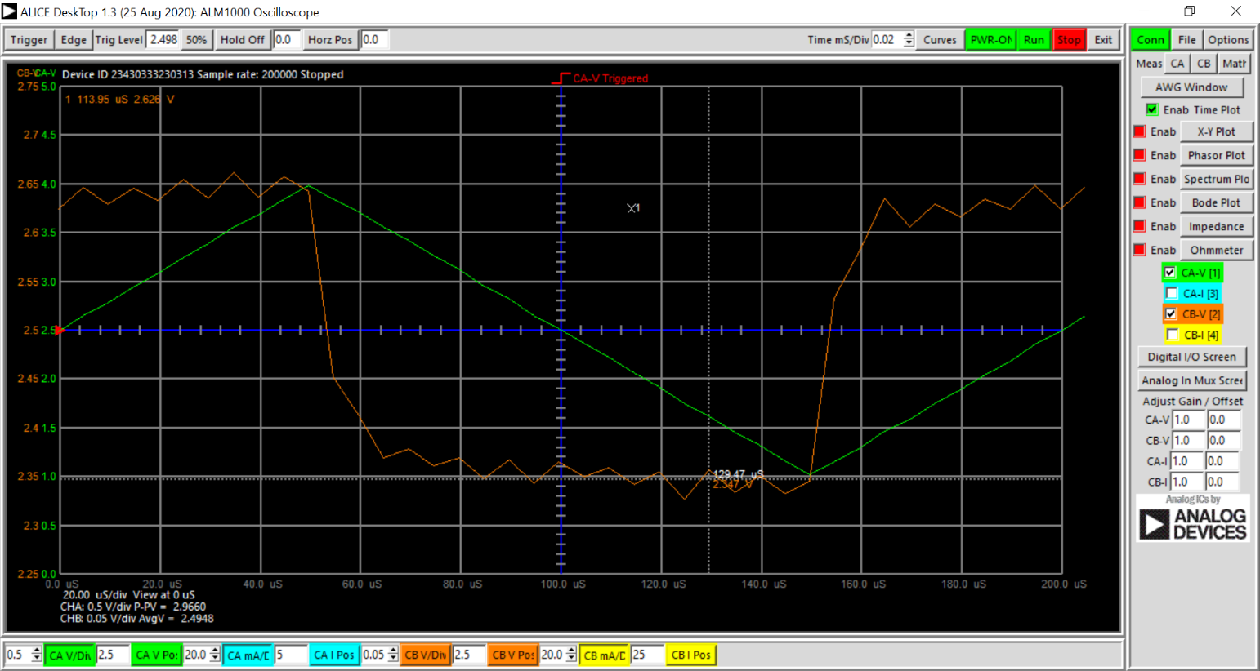On the Conn tool bar to the right, for the Meas(ure) toggle CA choose P-P under CA-V, and for the toggle CB choose P-P under CB-V. This will result in a readout of Peak-to-Peak voltages for both CA and CB in the lower left hand corner of the oscilloscope display (see the figure below).

This is where you measure $V_{exp}$

Voltage Step

**Figure 2**. The CB voltage step size (orange curve) is about 0.27 V in this example; a fall of the step occurs around $t=50 μsec$.

**Experimental Measurements**

* Read the CH B voltage at the edge of the step by clicking the STOP button at the top of the screen, then clicking on the orange CB-V/Div toggle on the bottom toolbar of the oscilloscope display; then move your cursor and clicking it on the step of the CB voltage just before it falls (orange curve, see the example figure above). If the cursor doesn’t allow you to make that voltage measurement, you could also find its value by just reading the left orange scale on the graph. Record this value as your experimentally determined inductor step voltage, $V_{exp}$.
* Next, read the CH A peak to peak (P-P) voltage from the bottom left corner of the display (or use the cursor and click the CA V/Div button the bottom of the oscilloscope screen, and measure the voltage change between the highest and lowest values of the input voltage signal CH A); record this as the peak-to-peak voltage, $ΔV_{pp}$.
* Click the RUN button and repeat the measurement for frequencies of 500 Hz, and 1.0, 2.0, 3.0, and 4.0 kHz. Fill in the Table below.
  + Column 1 – Frequency (given)
  + Column 2 – One half of the period $T_{1/2}$ of the triangle wave.
  + Column 3 – Peak to peak voltage $ΔV_{pp}$ supplied by the Channel A source.
  + Column 4 – Peak to peak current $ΔI_{pp}$ computed from Peak-to-Peak Voltage and the resistance in series with the inductor.
  + Column 5 – Rate of change of the current using $ΔI_{pp}$ divided by half the period.
  + Column 6 – Measured CB voltage $V_{exp}$ at the point just before the fall of the step.

Resistance = _______ Ω; $ΔV_{pp}=$_______V; Stated inductance =__________H

|  |  |  |  |  |  |
| --- | --- | --- | --- | --- | --- |
| These five columns are taken from the driving signal | | | | |  |
| Frequency  (Hz) | $$T_{1/2}$$ (= Period/2)  (s) | $$ΔV_{pp}$$ (= pk to pk Ch A Voltage)  (V) | $$ΔI_{pp}$$ (computed from $ΔV_{pp}/R$)  (A) | $$\frac{ΔI_{pp}}{T_{\frac{1}{2}}}$$ (A/s) | $$V_{exp}$$ (V) |
| 5000 |  |  |  |  |  |
| 500 |  |  |  |  |  |
| 1000 |  |  |  |  |  |
| 2000 |  |  |  |  |  |
| 3000 |  |  |  |  |  |
| 4000 |  |  |  |  |  |

* + Use the File menu to Save to CSV the Curve data from one of your frequencies. Import into a plotting program (e.g. – Excel).
* 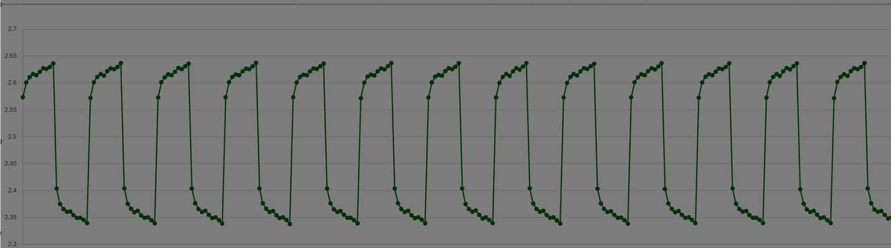Insert your plot of the example CB V scan vs time here.
* Plot $ΔV_{exp}$ as a function of ${ΔI_{pp}/T}_{\frac{1}{2}}$ here.

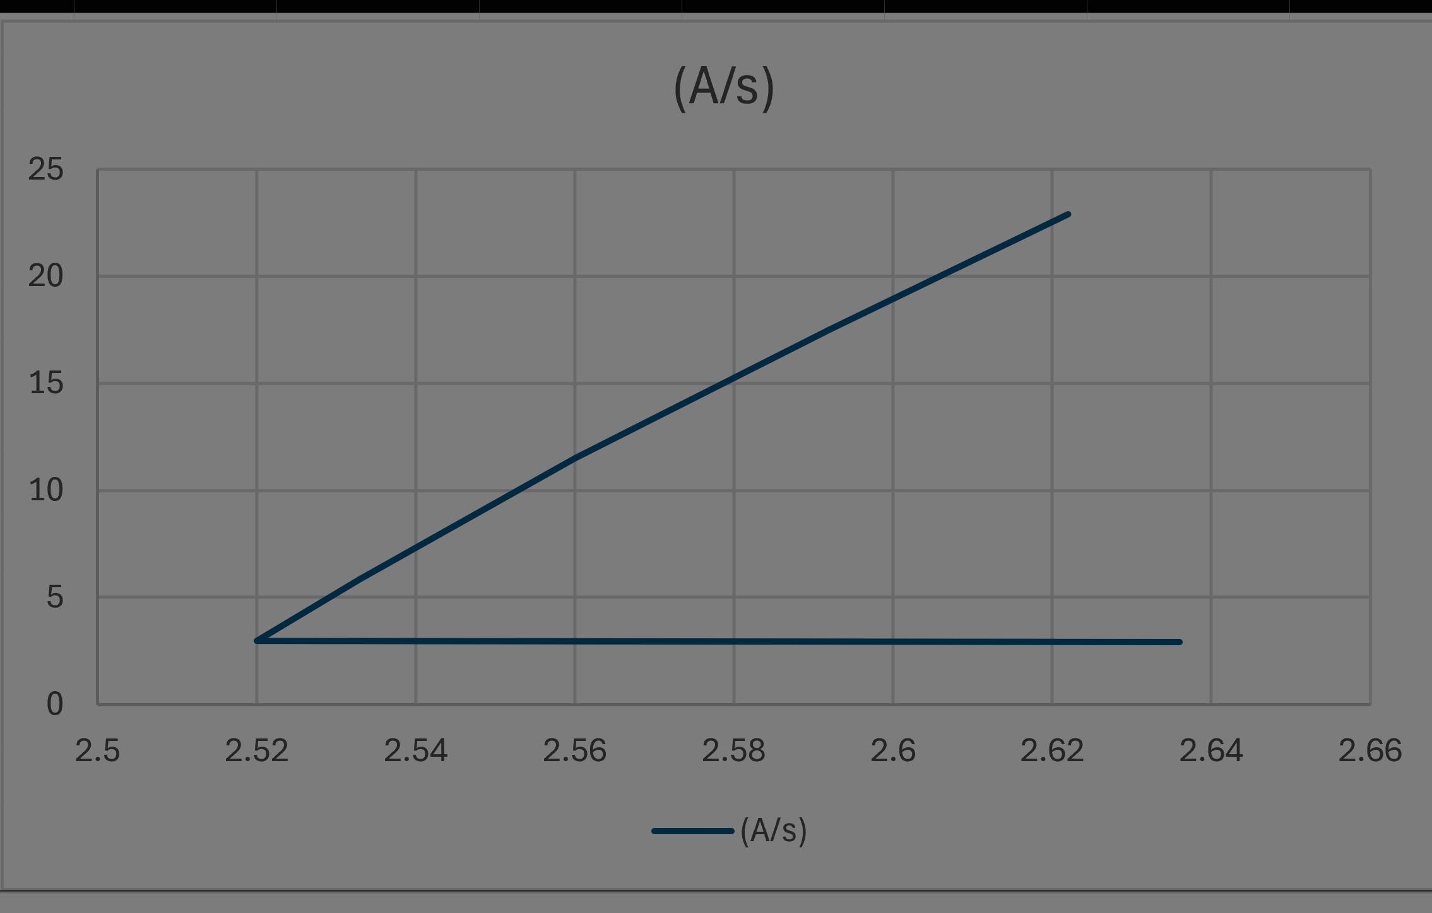

Plot from Matthew Ricobonno

* + Determine $L_{exp}$ from fitting a straight line to your plot of $V_{exp}$ as a function of ${ΔI_{pp}}/{T_{\frac{1}{2}}}$; the slope of the resulting trend line will be $L_{exp}$. How does your experimental value compare with the stated value of $L$?

# 30C – M1K Extra Credit (3 extra-credit lab pts) - Experiment: *EMF* and Current Relationship in a Capacitor

**Background calculations**

The potential across a capacitor is proportional to the charge on the capacitor:

$$V_{C}= Q/C$$

So, in a series RC circuit the relationship between the potential and the current is:

$$V_{C}(t)= V_{C}\left(0\right)+\frac{1}{C}\int_{0}^{t}{I(t^{'})dt'}$$

The resistor, capacitor, and driving frequency in this experiment are chosen so that the current in the circuit is limited by the resistor, so $I(t)= \frac{V_{applied}(t)}{R}$. If the driving potential is constant, then $$V_{C}(t)= V_{C}\left(0\right)+\frac{1}{C}\frac{V_{applied}}{R}t$$

1. Assume that *Vapplied* = 4.0V, R = 2000 Ω and C = 1.0x10-6 F, and . Assuming also that the current is limited entirely by the resistance, calculate the charge on the capacitor after 2.0x10-4 s.

_______________C

1. Assuming the same conditions as above, calculate the potential across the capacitor after 2.0x10-4 s.

1. Sketch the expected signal on the grid to the right for the parameters above if the applied voltage is a square wave that starts at time = 0 s at +4.0 Vand switches from +4.0 V to -4.0V at 2.0x10-4 s and then back to +4.0 V at 4.0x10-4 s.

For a more general case of an applied square wave potential with $V_{C}\left(0\right)≠0$,

$V_{C}\left(t\right)=V_{C}\left(0\right)+ \frac{ΔV_{pp}}{2RC}t$,

where $ΔV_{pp}={(V}_{applied,max}-V_{applied,min})$; $V_{applied,max}$ is the maximum potential of the applied square wave, and $V_{applied,min}$ is the wave’s minimum potential. This expression is consistent with our example calculation in parts 2 and 3 above, because, for that case, $V_{applied,max}=V_{applied}=+4.0 V$, $V_{applied,min}={-V}_{applied}=-4.0 V$, and $V_{C}\left(0\right)=0$. Using this more general expression, the capacitor charge at half the square wave period (when the capacitor reaches its peak, i.e., maximum value) can be written as

$Q\left(T_{1/2}\right)=CV_{C}\left(T_{1/2}\right)=Q\left(0\right)+\frac{ΔV_{pp}}{2R}T_{1/2}=Q\left(0\right)+δQ$,

where the peak-to-peak added charge $δQ=\frac{ΔV_{pp}}{2R}T_{1/2}=I_{C}T_{1/2}$, and $I_{C}=ΔV_{pp}/2R$ is the charging current when the applied square wave is at is maximum potential. Therefore, the change in the capacitor voltage over the charging wave half period is

$ΔV_{C}=V_{C}\left(T_{1/2}\right)-V_{C}\left(0\right)=δQ/C$.

**Experiment:**

You will construct an RC circuit in which the current for the time period observed is controlled by the resistor and the function generator amplitude.

**Equipment:** M1K or similar board; $1000 Ω$ resistor; 2.2 μF (or similar) capacitor; 3 jumper wires.

Set-up

* Set up the circuit as described in the previous module, replacing the inductor with the capacitor.
* Set up the ALICE oscilloscope using Ch A as the potential source.
  + Use the AWG Configuration Panel to set up the measurement channels.
    - AWG CH A
      * Mode = SVMI with Term = To 2.5
      * Shape=**Square**; Freq Ch A=5000 Hz
      * Min Ch A = 1.0; Max Ch A = 4.0
    - AWG CH B to Hi-Z with Term=Open (This disconnects B from its source voltage. Other settings are unimportant.) Also, uncheck Sync AWG.
  + On the menus bar across the top of the oscilloscope frame
    - Curves menu, choose CA-V and CB-V
    - Trigger menu select CA V and Auto level.
    - Edge menu = Rising
    - Time mS/Div = 0.02 mS/Div
  + On the settings bar across the bottom of the oscilloscope select settings for CA V/Div, CA V Pos, CB V V/Div, and CB V Pos to get both Channel A and Channel B Voltage on the screen with each signal filling most of the vertical range. (You will find it best to set the CA and CB V Position to 2.5 V.)
* Copy and paste a screen shot of the oscilloscope here.

**Experimental Measurements**

* Read the amplitude of the CH B voltage step by selecting the CB button on the CONN menu panel on the right of the ALICE screen and displaying the peak-to-peak (P-P) voltage as done earlier for the inductor-resistor series circuit. (You can also just estimate by reading the scales on the graph.)
* Click the RUN button and repeat the measurement for frequencies of 500 Hz, and 1.0, 2.0, 3.0, and 4.0 kHz. Fill in the Table below.
  + Column 1 – Frequency (given)
  + Column 2 – One half of the period $T_{1/2}$ of the square wave.
  + Column 3 – Peak-to-peak voltage $ΔV_{pp}$ supplied by the Channel A source.
  + Column 4 – Capacitor charging current $I_{C}$ computed from peak-to-peak voltage and the resistance in series with the capacitor.
  + Column 5 – Change in charge on the capacitor $δQ$ computed from the current and the period of the square wave.
  + Column 6 – Measured magnitude of the voltage step $ΔV_{exp}$ due to the charging by the applied current. This is the peak-to-peak voltage for CH B.

Resistance = _______ Ω; Stated Capacitance =__________F

|  |  |  |  |  |  |
| --- | --- | --- | --- | --- | --- |
| Frequency  (Hz) | $$T_{1/2}$$ (=Period/2)  (s) | $$ΔV_{pp}$$ (= pk to pk  Ch A voltage)  (V) | $I_{C}$ (computed from $ΔV_{pp}/2R$)  (A) | $$δQ=I_{C}T_{\frac{1}{2}}$$ (C) | $$ΔV_{exp}$$ (=Ch B pk to pk voltage)  (V) |
| 5000 |  |  |  |  |  |
| 500 |  |  |  |  |  |
| 1000 |  |  |  |  |  |
| 2000 |  |  |  |  |  |
| 3000 |  |  |  |  |  |
| 4000 |  |  |  |  |  |

* Plot $ΔV_{exp}$ against $I_{C}T_{\frac{1}{2}}$ below and determine the capacitance from the slope using

$$I_{C}T_{\frac{1}{2}}=δQ=CΔV_{C}=CΔV_{exp}$$

Copy your plot into this space.

* Compare your experimental value of the capacitance with the reported capacitance.

# Supplementary: A beginner’s guide to starting up with your ADALM1000 (M1K) board and components

## *Electronic Breadboards*

Electronic breadboards have lots of simple connectors for electronic components. Holes in rows and columns are usually connected to one another so it's easy to connect components to each other. The interconnect layout for a typical breadboard is shown in Figure S1 here. (A few typical devices are also shown to indicate how they might be inserted in the breadboard.)

The leads of most components and your jumper wires can be pushed straight into the holes. ICs are inserted across the central gap with their notch or dot to the left.

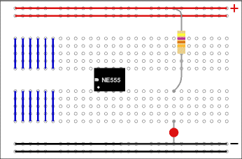

*Figure S1. Electronic breadboard configuration.*

The double top and bottom strips are usually designated to carry power or common signals – you have 30 pins connected in a row. The groups of five (with blue line in the image) running vertically are called terminal strips. Each vertical group of 5 (terminal strip) is wired together inside the board and make it easy to connect devices together.

***Components:***

The PHYS 1200 M1K-electronics kit typically includes at least the following (shown in the Figure S2 below):

* Circuit breadboard (1).
* 100 Ω resistor - plugged into terminal strip 1 of the breadboard.
* 470 Ω resistor - plugged into terminal strips 7/8 of the breadboard.
* 1000 Ω resistor - plugged into terminal strip 4 in the following image.
* Diode – plugged into terminal strip 12.
* 2.2 microFarad capacitor - plugged into terminal strip 15.
* 4.7 milliHenry inductor - plugged into terminal strip 30 in the following image.
* Diode - plugged into terminal strip 12.
* 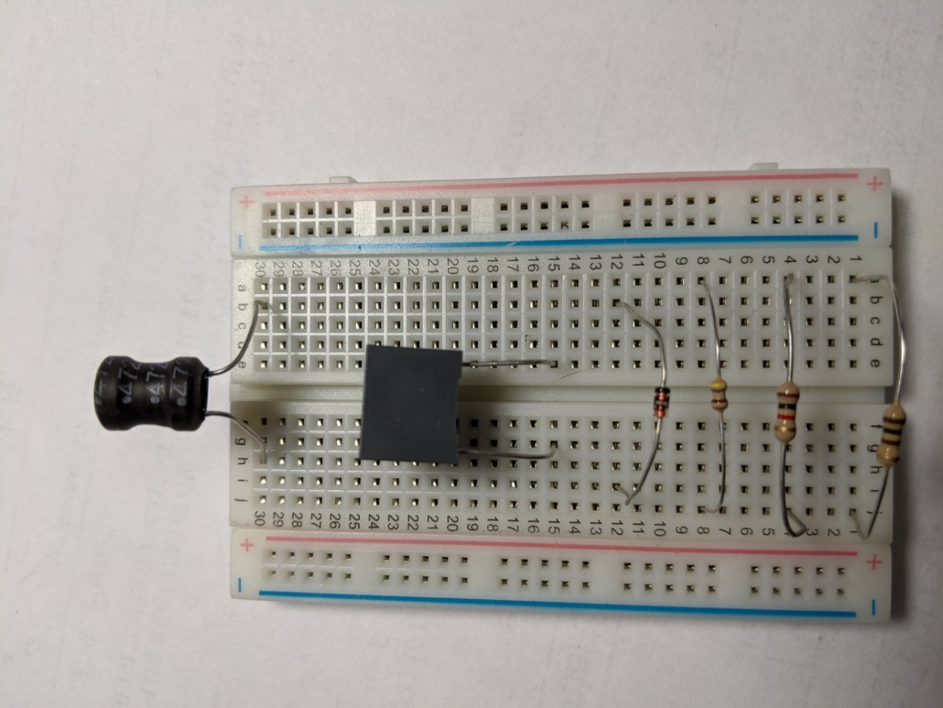Jumper wires – not shown (Jumper wires arrive as an attached group. You can separate them into individual wires.)

*Figure S2. Images of components plugged into terminal strips.*

## *Software Set-up*

Set up the software before connecting your ADALM1000 board to your computer. Upload PixelPulse software first, and then ALICE. See the document by Nate Hodge (ALICE installation guide) for tips. It is in the Lab Information folder in LMS, and also the Class 14 folder as well.

## *Getting analog signals in and out of the M1K*

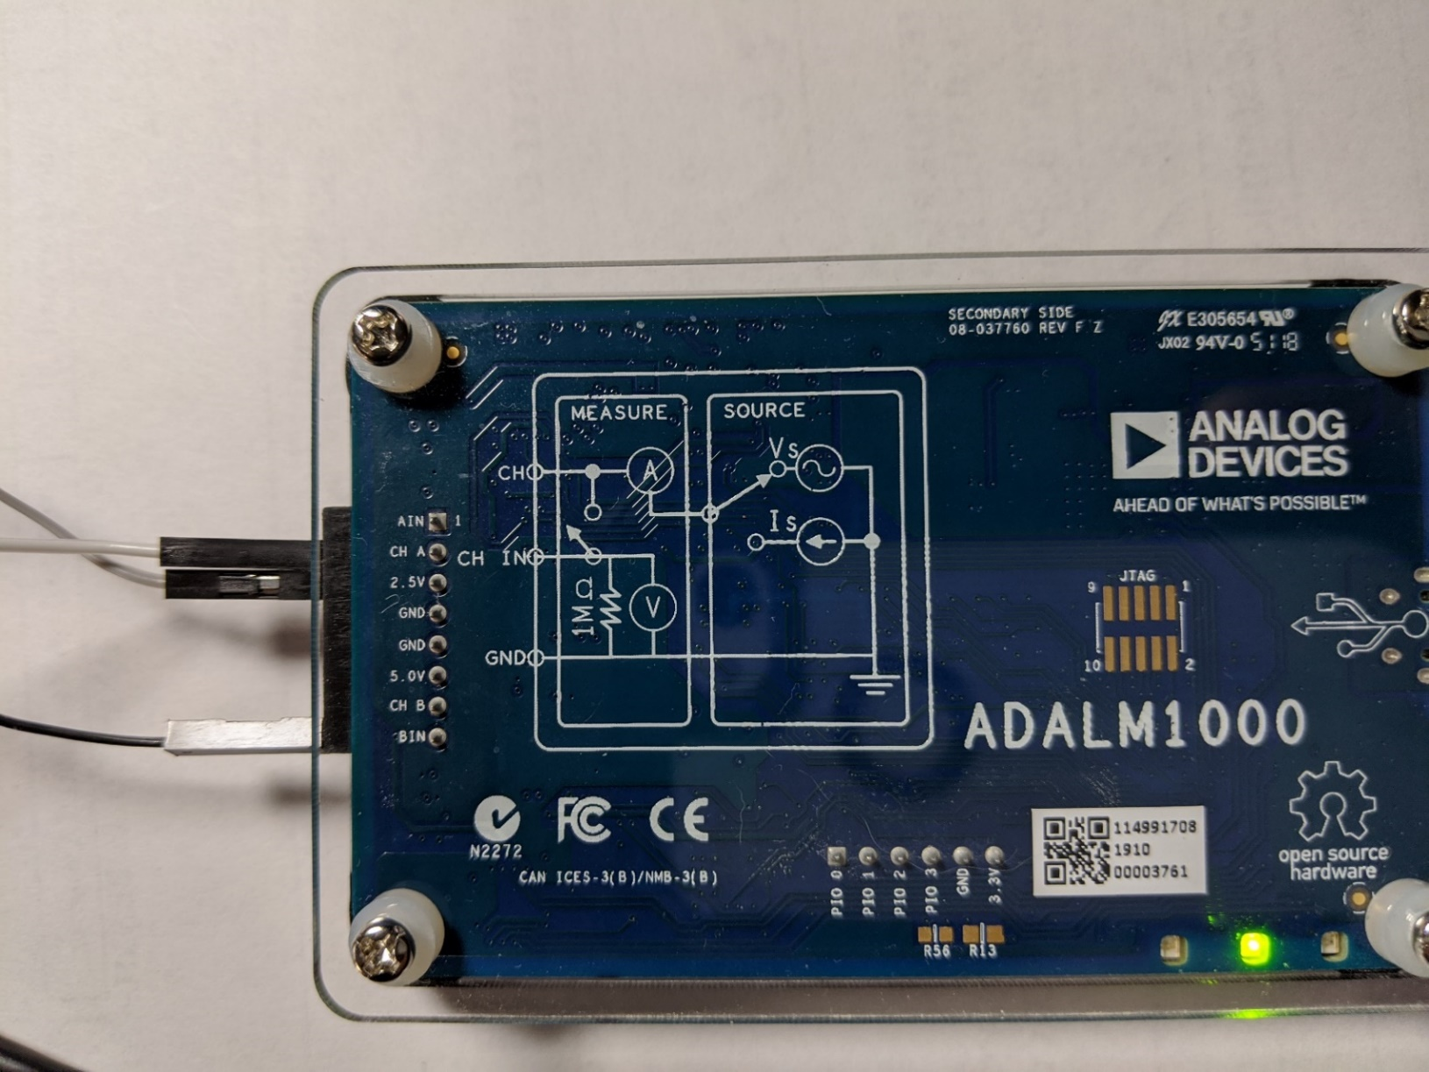There is a set of holes into which jumper wires can be plugged at the left end of the M1K, as shown in Figure S3. [Three jumper wires are plugged in in the Figure: Ch(annel) A, 2.5V output, and B in (Channel B input).]

*Figure S3. The ADALM1000 board showing the connector strip with three jumper wires plugged in. Note that a green light shines when the board and the ALICE software are functioning correctly.*

In PHYS 1200 we will usually use Channel A as a source channel and use the Arbitrary Wave Generator (AWG) to power it.

M1K channels are:

A IN – Channel A voltage measuring input with 1 MΩ input impedance.

CH A – Channel A output or input.

2.5 V – This is a 2.5 V dc source that is frequently used as the reference potential for measurement.

GND – Ground (2 of them)

5.0 V – 5.0 V dc source.

CH B – Channel B output or input.

B IN – Channel B input voltage measurement.

## Figure 4*Two of the ALICE M1K Desktop Set-Up Control Panels.*

*Figure S4. Two panels associated with the M1K Desktop. The AWG Configuration panel (right, here) appears as a separate window. The connection panel (left, here – see also Figure 2 on p. 4) is on the right-hand side of the oscilloscope.*